II. Executive Summary
 Business Plan

From: Lutz Müller
Sent: Monday, June 06, 2011 9:51 AM
To: r.lehmann@kandl.asia
Subject: Business Plam Aslan

Hi Rene
Anbei der Business Plan zurück.
Ich habe die erste Seite angepasst, die Arbeiter auf 67 angepasst. Aufstellung und Organigramm angepasst ( Worker und Aufteilung) und den Finanzplan entsprechend geändert.
Ich hoffe alles ist OK jetzt.

Mit freundlichen Grüßen
Kind Regards

Lutz Müller
Schillerstr. 6
78144 Tennenbronn

Tel : 49 7729 918893
Mobile:+49 172 7626638
Email: lutzhmueller@arcor.de

Table of Contents
I. Table of Contents 2

II. Executive Summary 3
III. General Company Description 5

IV. Organizational chart
V. Financial Plan 13

The proposed project describes the launch of production of sausages in Almaty.
1. The volume of production is 5-10 tons a day with increased volume up to 40 tons daily in 4 years
- production area - 2000 sq m
- The number of employees - 67 persons.
2. The amount of funding 5,120,000 Euro
- Equipment - 2,775,500 Euro
- Construction - 1,200,000 Euro
- Working capital - 1,145,000 Euro
3. Expected profit for the first year - 5,146,300 Euro
4. Payback period - 1,5 years

Currently every day the number of Muslims is growing up in the world, in this regard it the growing the number of people feeding halal products.
Now there are about ten major producers of halal sausage products that at this stage are not enough.
We visited several international exhibitions of halal industry, to our astonishment assortment of sausages are not very rich, and we decided to form a Join Company with the German team of professionals from Bavarian Sausage Co., Ltd.
We also held a marketing researching which has revealed huge demand for consumption by military men and other remote regions of canned products (as well as for the hot dogs) in Islamic countries, and consumption in restaurants in which the range of halal products are also is rather poor. We already have a request for the supply of chicken sausages to India, Pakistan, Indonesia, Malaysia not less than 200 tons a month, that guarantee success of this business project on 100% (copy of email requests are attached).
German specialists from Bavarian Sausage Co., Ltd. professionally work in the market for many years and have a wealth of experience in organization of management and control of production in accordance with international halal standards GMP, HACCP, FDA which guarantee the quality and unique taste of the products. We also will have international Halal certificate and ISO certificate.
We will produce halal sausage products under Bavarian know how to provide assortment of sausage productions of a different kind: ham, smoked meat, different kinds of sausages (our experts can produce about 200 kinds of sausages from one kind of meat), as well as meat cuts that will provide a wide choice in territory of Kazakhstan, as well as near and far abroad.

Market for halal goods and services in Europe, of course, is under development. It is largely unregulated, but at the same time, recent researching shows that 75 percent of European buyers, including non-Muslims are willing to pay 10 percent more than the market price for the products of better quality, which is rightly considered halal. In the producing of halal products with European producers also follow EU instructions, the aim of which is to make safe food

We plan to distribute our products according to the scheme below

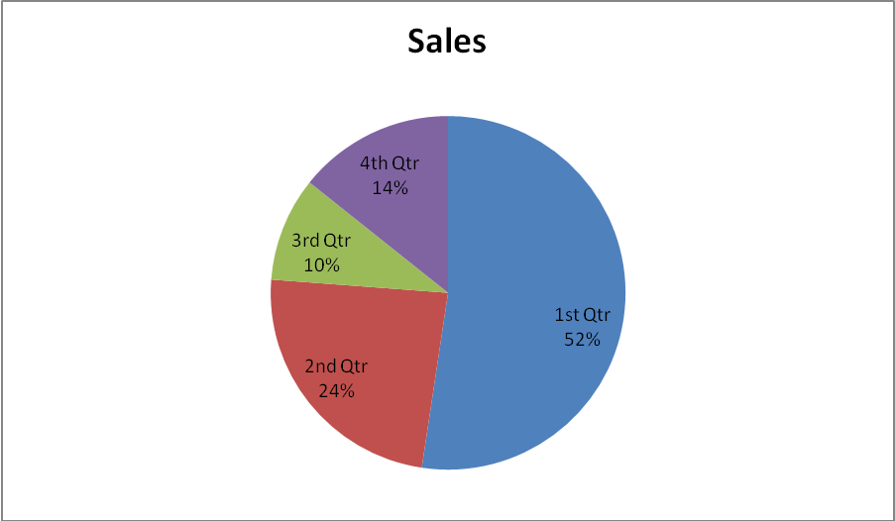

1) Exports to the Islamic world.
2) Supermarkets and shops.
3) Markets.
4) Restaurants and hotels.
III. General Company Description
We have studied the local market and are going to purchase only tested and certified halal meat products from selected slaughterhouses around Almaty to secure areas to ensure the freshness of our products.
For exports of the productions we selected a few chicken farms that produce halal chicken. Also there are foreign suppliers who are ready (in case of shortage of raw materials) to supply a necessary amount of meat products for our work process with 2 shifts 6 days a week.
Our hygienic standards correspond with the international standards such as GMP, HACCP, FDA.
We ready to create a new taste or improve and adjust existing recipes of our company and create a new brand in a short period.
First construction stage

Building area – ​​2,000 square meters
Projecting and coordination - 100,000 Euro
Construction - 1,200,000 Euro
Reception is necessary:
APL - Architectural and Planning Assignment
Project preparation
Master plan and project coordination in Construction and Architecture Department
Coordination with in Sanitary & Epidemiological Service (SES)
Coordination with Fire Engineering Service (FES)
Getting specifications (necessary volume of electricity and heat)
In conclusion, obtaining a building permit in GASK
Coordination with public utilities (Heating Electrical Station, Agro-Industrial Complex, etc.)
Construction period - 5 months
Delivery period of equipment - 1-2 months
Total construction period - 7-8 months

For construction will be used hangar type technology, which allow to build a necessary heat-insulated space of 2,000 square meters in a very short period of time (see pictures below).

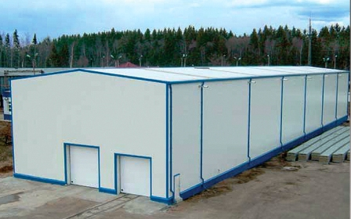 | 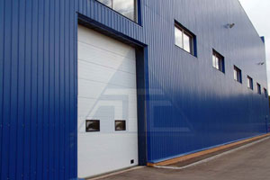

Second construction stage

Delivery and installation of necessary equipment made ​​in Germany:

No. | Machine | Brand | Volume | Price (Euro)
1 | 2 x Filling Machines including Hanging lines |  | max.4000 Kg p. H. | 255,000.00
2 | 2 x Clip machines Automatic KDCM-A 400 |  | max.4000 Kg p. H. | 82,000.00
3 | 2 x Bandsaws |  | max.2000 Kg p. H. | 19,500.00
4 | 2 x Bowl Chopper 200 Liter |  | max.3000 Kg p. H. | 400,000.00
5 | 2 x Smokehouses including 8 Trolleys and Cooling |  | max.2000 Kg p. H. | 185,000.00
6 | 1 x Slicer including Scale and Automatic system |  | max.2000 Kg p. H. | 153,000.00
7 | 1 x Injection machine |  | max.2000 Kg p. H. | 59,000.00
8 | 1 x Tumbler for Ham |  | max. 600 Kg p. H. | 45,000.00
9 | 1 x Cube Dicer |  | max. 600 Kg p. H. | 35,000.00
10 | 2 x Scales |  |  | 15,000.00
11 | 1 x Sausage cutter |  | max.1000 Cut p.M | 50,000.00
12 | 1 x Packing machine automatic |  | max.2000 Kg p. H. | 125,000.00
13 | 1 x Flaker for frozen Meat |  | max.2000 Kg p. H. | 35,000.00
14 | 1 x Ripe Room for Salami and Hams |  | max.1000 p. Day | 52,000.00
15 | 1 x Mincer with loading system |  | max.3000 Kg p. H. | 40,000.00
16 | Production line for the cans |  |  | 600,000.00
17 | Cooling machines |  |  | 500,000.00
18 | Boiling Kettle |  |  | 25,000.00
19 | Hygenic articles |  |  | 80,000.00
 | Total |  |  | 2,775,500.00

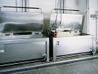 | Boiling Kettle
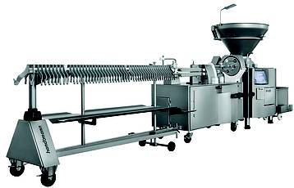 | PVLH 228  The special new feature of the PVLH 228 linking and hanging line, exhibited for the first time at the IFFA 2010, is then new linking unit with 2 nozzles. Linking unit: When operation is stopped, the automatically moves out of the casing brake (linear movement). To change the casing, the operator then uses the 2-handed operating system. The revolving head tilts and moves linearly into filling position.
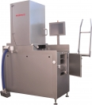 | 56 needles process with the help of novel solutions up to 5.000 kg per hour and the belt width of 350 mm guarantees comfortabel working. The IR 56 curing centre ist not only outstanding through novel machine concepts which lead to better results, but also saves time and achieves visibly better product criteries.
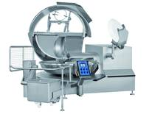 | The SwopperV combines functionality with state-of-the-art technology. It is extremely universal, but nevertheless a special machine for every application. The operator monitors the cutting process through a solid noise cover made of 4 cm thick acrylic glass. Shorter loading and unloading times thanks to a new sight cover design and coordinated movements (for example noise cover with ejector) provide further considerable increase in productivity. A sensor in the splash guard measures the temperature precisely and as dynamically as a probe thermometer.
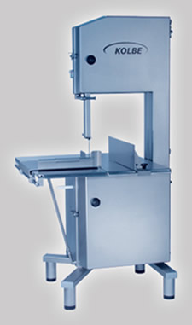 | K 430  The best performance band saw K 430 of the KOLBE SuperProfiLine equipped in series with fixed table and additional sliding table for heaviest demands to cut performance. Predestined for use in the shift operation.
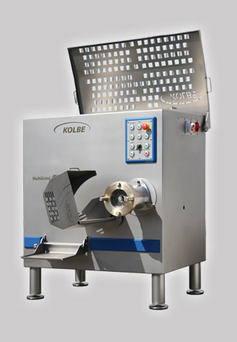 | AW/AWM 160/56  The KOLBE grinders serie MultiGrind are heavy duty industrial machines designed specifically for large volume mixing and grinding. KOLBE´s high standards of construction and finish deliver consistent reliable machines, which can be equipped with cutting-system Unger or Enterprise.
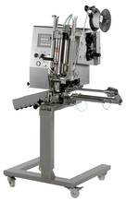 | KDCM200  The KDCM series is a new, completely redesigned series of semi-automatic and fully automatic machines in modular design. The basic and add-on components of these stainless steel clipping machines for the food industry are exchangeable throughout the entire series, which means that each model can be easily optimised to suit the desired application in each case. A table-top machine – ideal as an entry-level model for the craft business – grows with the production process: Due to the use of an optional roller frame and other equipment options such as the automatic looper, thread dispenser, spool clip, and further similar items, this model is turned into a high-performance clipping solution that can be combined with virtually any stuffer for production processes in trade and industry.  Natural, artificial and fibre casings in the gauge range of 25-110 (120) mm are processed as raw, cooked and boiled sausages into portion sausages, sausage rings, sausage chains, and stick sausages, which run out in a discharge tray or on different roller conveyors. The movable, adjustable casing brake prevents casing overload and ensures portion-precise stuffing. Handling, conversion, cleaning, and maintenance are ideal. The machines have wide-opening hoods and are easy to inspect thanks to the inclined position at an angle of 10 degrees; beyond that, the machines can be swivelled.  The components made of stainless steel, inclined surfaces and a new design with free-hanging matrix plates meet highest hygiene requirements. With the electronic counter, 20 comfortable memory programs are available for the semi-automatic machine KDCM.
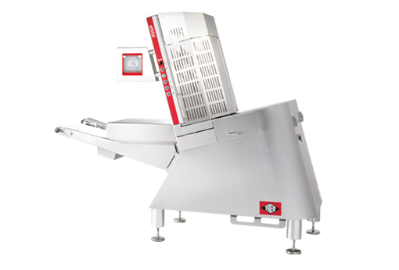  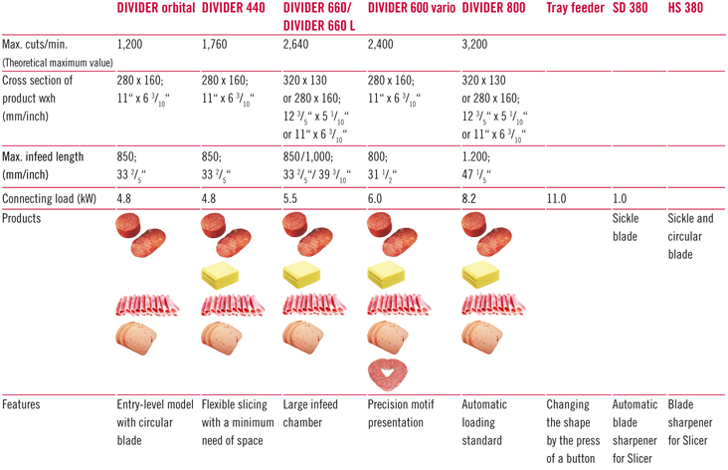 | The DIVIDER orbital is the perfect solution for anyone requiring a compact slicer that takes up little space (e.g. as a first step towards professional slicing) while still maintaining an adequate level of performance. The DIVIDER orbital is fitted with circular blade. So TREIF is the only manufacturer of slicers which offers both circular and sickle blade technology within this category of slicers. The slicer offers the possibility to slice numerous products with its circular blade, without the need to make any conversions to the machine. Boiled sausage and salami products, boiled and raw ham, and even cheese, are especially suitable for this slicer.  The machine always achieves optimum product presentation with the world‘s unique, patented SAS system. SAS stands for “Stacking/Shingling As you Slice”. Both are carried out in one operating process, so that the slices cannot fall or slip. One of the most recent TREIF patents involves combining the SAS system with circular blade technology.
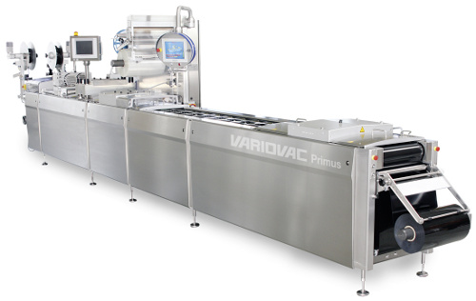 | VARIOVAC Primus, the multifunctional, convenient and approved vacuum packaging machine  The VARIOVAC Primus is a versatile, high-capacity machine. Whether you need semi-rigid or flexible packages, food, non-food or medical disposables, the proven capability of the Primus can offer the right solution for your requirements. The modular construction and the variety of machine widths give an almost infinite number of packaging options.

Delivery of the equipment is made within 1-3 months.

The company will be working under Germany know how. We will be equipped with modern production facilities according to the newest standards.
The production room will be arranged according to the newest German standard (high ceiling, cooling equipment, rooms and freezer room installed with a German electrician to secure a continuous cooling of the merchandise.

Stage 3 - Staffing
Need 2-3 months for staff training by German experts who are specially arrive for, as generally all of the equipments are computerized that make more easier the work of professionals and provide high quality and the quantity of production.

Staff will be selected from the orphanage "Parzant" with a Muslim bias. Adolescents aged 18, will be trained by German experts and be able to purchase a reliable well-paid job. Our company also intends to allocate 20% of the profits to children's education and development of children's homes.
The Staff costs will be per month: 30 workers common staff 13.000 USD
10 workers quality grade 10.000 USD
2 workers specialist mechanics 5.000 USD
1 Housekeeper 1.000 USD
3 Driver 2.500 USD
4 Helper 2.000 USD
10 Office Staff 10.000 USD
4 Quality Controller 5.000 USD
3 Specialists from Germany 14.700 USD + Expenses(Flight,House,Transportation) -----------------------------------------
Expenses (Flight, House, Transportation for the specialists) per month 63.200 USD +

Expenses (Flight, House, Transportation for the specialists) per trimester 189.600 USD +

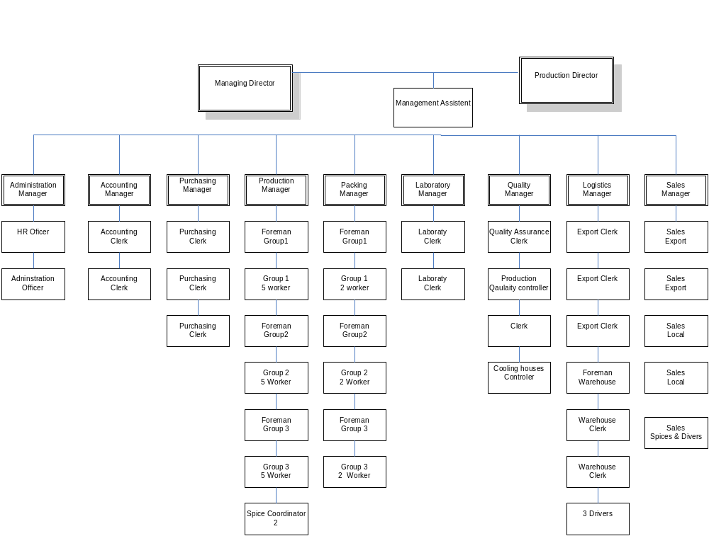IV. Organizational chart


